 | INTERLOCKING  Performance Innovations Ltd.  Tel: 604-940-0068  www.keyinterlocking.com | Bill To | Ship To | Purchasing Agents Name | End User
Name
Phone
Fax #

  Account Number | PO Number | Date Required | Date | Page 1 of
A. Lock Type
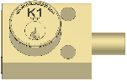 |  |  |  | 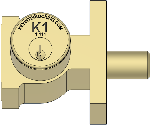 |  | 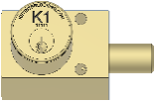 |  |  | 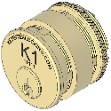 | 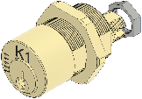 |  |  | 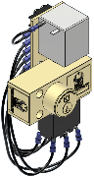 |  | 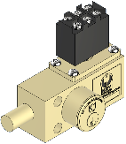
VF | VT |  |  | VB |  | VN | VD |  | CM | VC | VP |  | SKR |  | VFSA
B. # of Cylinders |  |  | C. BOLT LENGTH  In withdrawn position |  | D. Bolt Orientation |  |  | E. Key Removable Position |  | F. # of Cylinders “W”  for Multiple Cylinders |  | G. Options |  | H. Key Interchange
Use “1” for 1 cylinder  2 for 2 9 for 9  3 for 3 A for 10  4 for 4 B for 11  5 for 5 C for 12  6 for 6 D for 13  7 for 7 E for 14  8 for 8 F for 15 |  |  | USE “000” FOR 0" BOLT  025 1/4”  037 3/8”  050 1/2”  062 5/8”  075 3/4"  100 1”  125 1 1/4”  137 1 3/8”  150 1 1/2"  200 2”  300 3” |  | USE “ L” for bolt left  USE “R” for bolt right    BOLT LEFT    BOLT RIGHT |  |  | For single cylinder locks  use “E” for key released in  bolt extended position  For multiple cylinder locks  use “E”. Multiple cylinder interlocks always have the first cylinder “E”. Complete F section for multiple cylinder locks |  | Leave blank for single  Cylinder locks.  For multiple cylinder locks  List the number of withdrawn cylinders.  Example for 3 cylinder lock  EEE use “0” EEW use “1”  Use “A for 10 “B” for 11  “C” for 12 “D” for 13  “E” for 14 “F” for 15 |  | S Switch 1no 1nc  D Dust cover  A VD Adapter  P Roll Pin  B Button  SB Switch + Button |  | Examples  A1  A2  B1  B2

Item # | Qty | A | B | C | D | E | F | G | H | Remarks | Unit Price | Amount
1
2
3
4
5
6
7
8

Item # | Qty | A | B | C | D | E | F | G | H | Remarks | Unit Price | Amount
9
10
11
12
13
14
15
16
17
18
19
20
21
22
23
24
25
26
27
28
29
30
31
32
33
34
35

